**Espresso Coffee Maker**

**Instruction Manual**

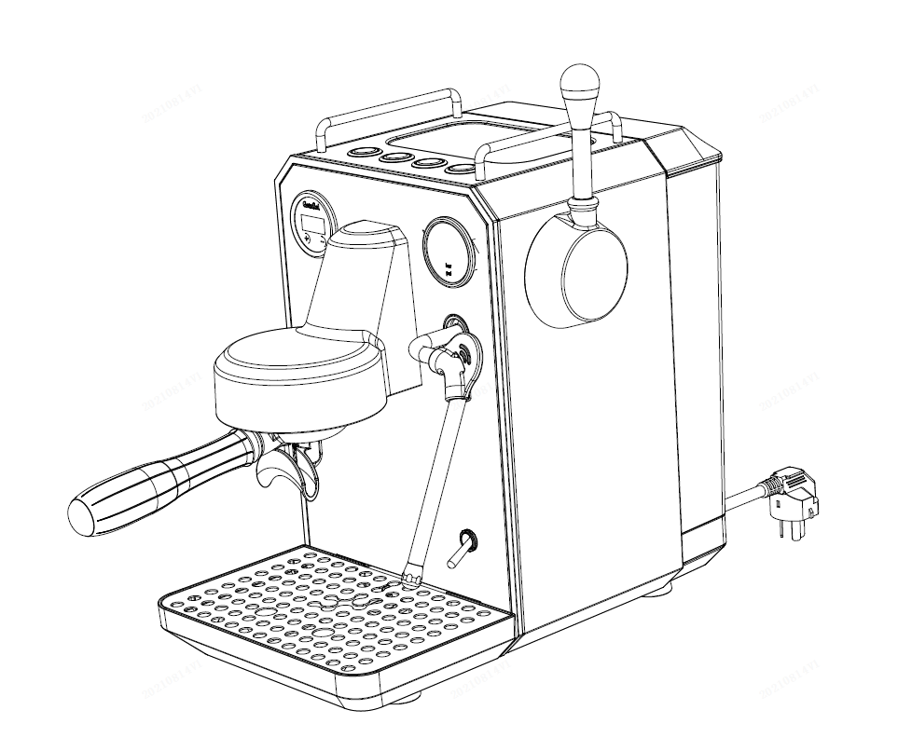

|  |  |
| --- | --- |
| **Item** | **AVX EM1 LUX** |
| **Voltage** | **220-240V～** |
| **frequency** | **50Hz/60Hz** |
| **Power** | **1550W-1850W** |
| **Water tank** | **1.7L** |
| **Pressure** | **15Bar** |

**\*IMPORTANT SAFEGUARDS：**

Before using machine always carefully read and comply with all these instructions. We cannot accept any responsibility for the consequences of improper use.

1. Check voltage to be sure that the voltage indicated on the name plate agrees with your voltage.
2. This appliance has been incorporated with a grounded plug. Please ensure the wall outlet in your house is well earthed.
3. Close supervision is necessary when the appliance is used by people. Place the machine out of the reach of children and persons with limited capabilities.
4. Do not place on or near a hot gas or electric burner or in a heated oven.
5. Unplug from outlet when not in use and before cleaning. Allow to cool before putting or taking off parts, and before cleaning the appliance.
6. Do not operate any appliance with a damaged cord or plug or after the appliance malfunctions, or has been damaged in any manner. Return appliance to the nearest authorized service facility for examination, repair or adjustment.
7. The use of accessory attachment not recommended by the appliance manufacturer may result in fire, electric shock, or injury to persons.
8. The appliance should be placed on table or flat place .Do not place the machine on the edge of desk or table.
9. Make sure that the power cord does not contact with the hot parts of the coffee machine.
10. Some parts temperature will be very high when machine is working, such as steaming pipe, steaming nozzle, funnel holder. Do not touch any hot parts to avoid scald, please use the funnel handle.
11. To protect against fire, electric shock and injury to persons, do not immerse cord, plugs, or body of machine in water or other liquid.
12. It must be protected against freezing conditions, because there is residual water in the boiler and water pump, which will damage the machine when it becomes ice.
13. Once the fault, defect or machine drop caused by suspicious defect, unplug the power plug immediately, do not operate on the problem machine.
14. Do not use outdoors.
15. SAVE THESE INSTRUCTIONS.
16. Machine use condition: Room temperature: 0-55℃.

HOUSEHOLD USE ONLY

**\*Know your machine**

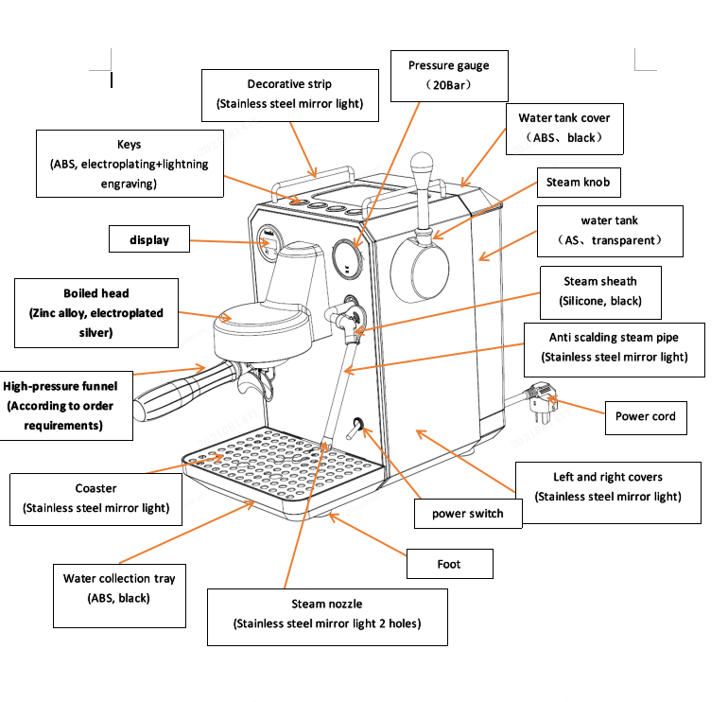

Warning: The machine must use a grinding Coffee powder and is composed of a central structure for obtaining espresso and steam.

**\*Operation function**

|  |  |  |  |
| --- | --- | --- | --- |
|  | Single cup button |  | Manual button |
|  | Double cup button |  | Steam button |

**Accessories：**

|  |  |  |  |  |  |  |
| --- | --- | --- | --- | --- | --- | --- |
| **Code** | **Name** | **Picture** |  | **Code** | **Name** | **Picture** |
| **A** | **Tamper** | IMG_256 |  | **B** | **Double cup filter holder** |  |
| **C** | **Cleaning pin** |  |  | **D** | **Brush** | IMG_256 |
| **E** | **Coffee spoon** |  |  | **F** | **Filter** | IMG_256 |

**\*A. FOR THE FIRST USE**

1. Move the coffee maker from the package, and check the accessories according to the list;
2. Clean all the detachable components;
3. Operation the appliance according to the section of “B” and “C” (no coffee powder in filter). Repeat 2-3 times.

**NOTE：For the first use, do not insert the porta filter holder, press the coffee button after power on, till there is water come out from brewing head, Then press the coffee button again to stop in order to prevent dry burning.**

**B. MAKE ESPRESSO COFFEE**

1. Open the lid, take out water tank, and pour appropriate water into tank. Do not exceed the MAX capacity;
2. Put back the water tank and close the lid;
3. Connect power plug, press power button, machine will automatically pump water about 2s,the buzzer will sound for 1s and display show “888”, then coffee and steam indicator lamp are flashing alternately, machine start preheating, preheating will be finished after 3min, all indicator lamp will always light on and display screen show “000” ;
4. Take out filter holder, pour appropriate coffee powder into the filter with coffee spoon, then press the coffee powder tightly, clean the extra coffee powder overflow the edge of holder, to avoid damage the seal ring of group head.

**Note: If too much coffee powder remaining in the edge of the filter, will easily to cause poor sealing and water leakage.**

1. Hold the upper part of machine with hand, lock the filter holder counterclockwise into the middle of the group head (must be tightened);
2. Put cup(s) under coffee outlet;
3. Press single cup/double cup/manual button to make coffee until the setting time (default time-Single cup:25s, Double cup:40s, Manual:120s), coffee is ready, machine will return to standby mode after 3s(at any time when making coffee, press single cup/double cup/manual button again to stop).

**Note: Close supervision is necessary when use the machine, because sometimes need manual operation.**

1. Remove filter holder after finished, knock it out and clean it with hot water immediately, and lock it again for next use.

**Note: Check frequently the water level in the tank. Refill if necessary.**

**Do not touch the hot surfaces of the machine with hands to avoid scald, especially** **brewing outlet, steam nozzle when use machine.**

* **How to make a good cup of coffee**

Grinding coffee bean and grinding quality largely determines the quality of coffee, the time should be 25s-30s to make a cup of coffee, if the powder is too coarse, coffee extract inadequate, the taste is light, and color is lighter, the cream also will be very thin, and color is white; if the powder is too fine, coffee over extraction, it will be too dark, and no cream. A good cup of coffee should use freshly ground coffee beans (use burr coffee grinder), and use appropriate amount of coffee beans. Each time when you making coffee with coffee powder, the freshness of the beans is very important, long time storage will make coffee bean oil decomposition.

**C. HEATING LIQUID (Steam function)**

1. Use a stainless steel cup, pour cold liquid to 1/2 cup;

**Note: Cup diameter should not less than 70 ± 5mm.**

2. Press steam button, it starts preheating, coffee indicator lamp will lights off and steam indicator lamp flashing, when steam indicator lamp keep lights on, preheating is finished;

3. Put a cup under steam nozzle;

4. Move forward the handle of the steam knob to turn on and release steam, let steam nozzle insert into the liquid;

5. Move backward the handle of the steam knob to turn off when desired temperature is reached, now steam is stopped, open knob again if you want to continue making steam;

**Note: Clean steam nozzle immediately after use, to prevent milk scaling.**

**Caution high temperature of hot water outlet when in use.**

**D. FROTHING MILK/ MAKE CAPPUCCINO**

1. Prepare espresso first with a large enough cup according to part “B. MAKE ESPRESSO COFFE’’;

2. Use whole, fresh cold milk out of the fridge(8℃-10℃), and pour 1/3 milk in cup;

**Note: Use a stainless steel cup, and cup diameter should not less than 70 ± 5mm, due to the volume of milk will increase after frothing.**

3. Press steam button, it starts preheating, coffee indicator lamp will lights off and steam indicator lamp flashing, when steam indicator lamp keep lights on, preheating is finished;

4. Put a stainless steel cup under steam nozzle;

5. Move forward the handle of the steam knob to release steam and frothing milk;

6. Remove cup when desired milk foam reached, then turn off knob, steam is stopped, pour the frothed milk into prepared espresso, now cappuccino is ready, you can add some sugar or Coco powder if you like it.

**Note: Purge steam to clean steam nozzle after use, warning hot surface.**

1. **SETTING BREWING TIME/PRE-INFUSION TIME**
2. **Brewing time:** open machine, long press single/double cup button, after 3s, machine will automatically pump water and coffee will come out, release the button after coffee reach your desired amount, setting is finished (Single/double cup setting range: 10-120s, not including the pre-infusion time,if the value is not in this range, it can not be saved).
3. **Pre-infusion time:** open machine, Long press “-” button, after 3s, display flashing “P02”, you can press “+” or “-” to adjusting the time, after appropriate time is reached and no operation for 5s, setting is finished.
4. The brewing time setting is not including the pre-infusion time, if including the pre-infusion time(0-30s), then the setting range is 10-150s.
5. **Coffee temperature setting**

1、Coffee temperature setting: Press and hold the "+" button on the display screen for about 3 seconds, and the number on the display screen will flash. Press and hold the "+" or "-" button to set the temperature value. After setting it, wait for about 5 seconds for the machine to automatically determine the changed temperature value, save the setting, and return to the standby state. The adjustable range is 80-102 ℃; The default temperature is 93 ℃。

1. DESCALING

**Note:When making coffee and steam for 500 times,machine will enter descaling reminder mode: display screen will show "Cln". It will automatically exits the descaling reminder mode and counting time again until you finished the descaling operation of the steam pipe (can make coffee and steam even under descaling reminder mode).**

1. Pour water and descaler into the water tank to the "Max" level (about 1.7L, ratio is 4:1, details please follow the instruction of descaler. Please use “household descaler”or you can use the citric acid replace descaler.(water and citric acid ratio is 100:3)
2. Rotate the steam pipe to the appropriate angle and wrap the steam nozzle in a cup (at least 1L).
3. Coffee part descaling: Long press manual coffee button 3s to enter descaling mode, the manual coffee button indicator light keep lights on,other buttons are flashing, water will come out 8s and stop 4s as one cycle and will keep operating for 5 cycles to do descaling for boiler and brewing head, it takes about 1min to finish the process.

4

4.Press manual coffee button one time to exit the descaling mode for coffee part.

5. Steam part descaling: Long press steam button 3s to enter descaling mode, the steam button indicator light keep lights on,other buttons are flashing, steam will come out for 1min to clean the steam pipe(Noted: should put a container larger than 600ml under the steam pipe to contain the water).

6. Press steam button one time to exit the descaling mode for steam part.

**\*CLEAN AND MAINTENANCE**

1. The machine has to be switched off and cooled down;
2. Clean housing with damp cloth;Note: Do not use abrasive sponges and alcohol or solvents. Do not immerse the machine into water.
3. Clean the outlet and the seal ring under the group head with professional brush;
4. Remove the filter and holder, knock out the coffee grounds inside, then clean it.
5. Clean all the detachable attachments in the water and dry thoroughly.

**\*CLEANING MINERAL DEPOSITS**

1. Machine builds up lime scale deposits over time and need descale it 2-3 months;
2. Pour water and descale in water tank up to MAX capacity (water and descale ratio is 4:1, follow the instruction of descale. Please use “household descale”, or you can use the citric acid replace descale (water and citric acid ratio is 100:3);
3. Lock filter holder (no coffee powder) into the group head. According to part “B”;
4. Press coffee button, then make about 150ml coffee after coffee indicator always lights on, turn off coffee button and turn on steam button, then open knob after steam indicator always lights on, release steam about 2min and turn off the knob, then make descales deposit in the machine at least 15min;
5. Repeat the steps 4 for 3 times;
6. Press coffee button to brew coffee until there is no descale left;
7. Make coffee again(no coffee powder), repeat the steps 4 for 3 times (no need wait for 15 min), then brewing until no water is left in the boiler;
8. Repeat the step 7 at least 3 times to make sure the piping is cleanly.

\*ANTIFREEZE STEPS

Note: if the temperature of the coffee machine is lower than the freezing point, it will cause damage to the equipment, In order to prevent the coffee machine from freezing and cracking during transportation or storage, the following steps must be followed before the coffee machine is shut down:

1. When the coffee machine needs to be shut down after use, take out the water tank from coffee machine first;

2. After taking out the water tank, press the coffee button to let the water out of the water outlet for 10 seconds, and then close the coffee button;

3. Turn off the coffee power after following the above steps;

4. Before using the coffee machine next time, install the water tank and operate normally.

**\*INDICATOR TIPS**

|  |  |  |  |  |  |  |  |
| --- | --- | --- | --- | --- | --- | --- | --- |
| **Single cup Indicator** | **Double cup Indicator** | **Maunal Indicator** | **Steam Indicator** | **Knob** | **Display screen** | **Cause** | **Solution** |
| Lights off | Lights off | Lights off | Lights off | Turn off | Display  “888” | Power on | **/** |
| Flashing | Flashing | Flashing | Flashing | Turn off | Flashing/ Display [=] | Coffee is pre-heating | **/** |
| Lights on | Lights  on | Lights  on | Lights  on | Turn off | Display seconds | Coffee pre-heating finished | **/** |
| Lights on | Lights  off | Lights  off | Lights off | Turn off | Display seconds | Making coffee  (Single cup) | **/** |
| Lights  off | Lights on | Lights  off | Lights off | Turn off | Display seconds | Making coffee  (Double cup) | **/** |
| Lights  off | Lights  off | Lights on | Lights off | Turn off | Display seconds | Making coffee  (Manual) | **/** |
| Lights  off | Lights  off | Lights  off | Flashing | Turn off | Flashing/ Display [=] | Steam is pre-heating | **/** |
| Lights  off | Lights  off | Lights  off | Lights on | Turn off | Display  “000” | Steam pre-heating finished | **/** |
| Lights  off | Lights  off | Lights  off | Lights on | Turn on | Display seconds | Making steam | **/** |
| Lights off | Lights  off | Lights  off | Lights off | Turn off | Display  “E1” | NTC was broken/Temperature lower than 1℃ or higher than 180℃ | Please contact with authorized service facility for repairing. |
| Lights off | Lights  off | Lights  off | Lights off | Turn on | Display  “E6” | Knob is turned on | Turn off the knob |
| Fast flashing | Fast flashing | Fast flashing | Fast flashing | Turn off | Display  “000” | Temperature is too high after turn off steam | Wait until machine cool down |
| Lights  off | Lights  off | Lights  off | Lights  off | Turn off | Display  “ECO” | Automatic shutdown after enter standby mode for 28min | Press any button to restart |
| Flashing | Flashing | Flashing,then lights on | Flashing | Turn off | Flashing/ Display [Cln] | Descaling for coffee part | Automatic exit after descaling for 1min |
| Flashing | Flashing | Flashing | Flashing,then lights on | Turn off | Flashing/ Display [Cln] | Descaling for steam part | Automatic exit after descaling for 1min |

**\*TROUBLE SHOOTING**

|  |  |  |
| --- | --- | --- |
| Problem | Cause/Result | Solution |
| No water comes out | Water tank is empty | Pour water in water tank |
| The input voltage or frequency is inconsistent with nameplate | Make sure the voltage and frequency is consistent with the nameplate |
| Machine malfunctions | Please contact with the authorized service |
| No steam is generated | Steam nozzle clogged | Clean steam nozzle |
| Water tank is empty | Pour water in water tank |
| Machine malfunctions | Please contact with the authorized service |
| Coffee runs out around the edge of the filter holder | Too much powder in the filter | Turn off the machine and wait for it cool down, clean the filter, then pour appropriate coffee powder |
| There is powder in the seal ring under group head |
| Implementation of the above operation problems still exist | Please contact with the authorized service |
| Coffee comes out too slow or no coffee comes out | coffee powder is too fine, and clogged filter | With thicker coffee powder |
| Filter holes are blocked | Brush / clean the filter |
| Water tank is not inserted | Insert the water tank in place |
| Water leakage on the bottom of machine | Drip tray is filled up | Please clean the drip tray |
| Machine malfunctions | Please contact with the authorized service |
| Machine is not working | The power cord is not plugged well. | Plug the power cord into a wall outlet correctly, |
| NTC is short circuit | Please contact with the authorized service |
| Machine malfunctions |
| The steam cannot froth. | Steam indicator not light on | Wait steam indicator lights on. |
| The container is too big or the shape is not fit | Use high and narrow cup or garland cup |
| Used skimmed milk | Use whole milk |

**\***If you have not been able to solve the problem, contact customer support in your country.

-

**\*DISPOSAL**

Please dispose of old machines in an environmentally neutral way.

Old machines contain valuable materials which should be salvaged for recycling. Please therefore dispose of old machines via your regional collection system.

**